

YEAR: 9
2018
SUBJECT: Science

TEST: Waves
TIME: 40 minutes
QUESTIONS: 15 Multiple Choice (15 marks)
8 Short Answer (15 marks)
TOTAL MARKS: 30 marks

DO NOT WRITE ON OR MARK THIS PAPER
SECTION ONE—MULTIPLE CHOICE (15 marks)

This section has 15 questions. Answer all questions on the separate Multiple-choice Answer Sheet provided.

1. The number of times per second that an object vibrates is called its

a) wavelength.
b) oscillation.
c) frequency.
d) amplitude.

2. The pitch of a musical note is the

a) amplitude
b) quality
c) size of the vibration
d) frequency

3. In an experiment at sea level, an explosive charge was detonated at the waters edge, represented by point X on the diagram.

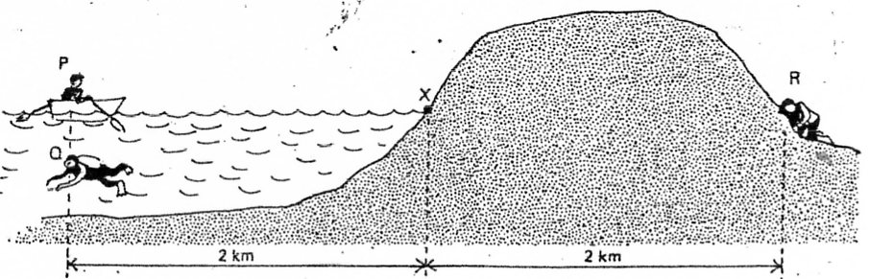

Three observers were located at equal distances from X. P in a boat, Q underwater and R with his ear to the ground.

Which one of the following statements is correct?

a) R hears the explosion first, then Q, then P.
b) P and Q hear the explosion first, at the same time.
c) P hears the explosion first, then Q, then R.
d) P and R hear the explosion first together, then Q.
4. Sound is a longitudinal wave. This means that in respect to the direction of the wave, its particles:

a) vibrate in parallel
b) move along with the wave
c) vibrate perpendicular
d) do not move at all

5. The speed of light travelling in a vacuum is equal to:

- 300 000 metres per second
- 300 000 000 metres per second
- 300 000 000 kilometres per second
- 330 metres per second

6. Two types of wave may be generated by using a slinky. The particles in the slinky can be moved in the same direction as the wave. What type of wave is made when this happens?

a) Transverse only
b) Longitudinal only
c) Transverse and longitudinal
d) Neither transverse nor longitudinal

7. The frequency of a note played on a piano is 128 Hz. The frequency of another note known as Middle C is 256 Hz. What can you tell me of the pitch of the first note compared to Middle C?

a) Higher than middle C
b) Lower than middle C
c) Same pitch as middle C
d) Louder than middle C

8. Combining all the colours of light together makes

- white
- black
- cyan
- red
9. An echo is an example of a sound wave
- refracting
- reflecting
- diffracting
- total internal reflection

10. A diamond has a beautiful sparkle because the light gets trapped inside it for a while before it emerges. What phenomena explain this?

- Refracting
- Reflecting
- Diffracting
- Total internal reflection

11. The volume of a musical note is the

a) amplitude
b) quality
c) size of the vibration
d) frequency

12. When putting a pen into a glass of water, the pen appears to bend. This bending of light is known as

- refracting
- reflecting
- diffracting
- total internal reflection

13. Which colours are absorbed by blue paint?
- blue only
- red, orange and yellow
- green, blue, indigo and violet
- red only

14. Sound moves fastest in

- warm air
- warm water
- cold water
- cold steel

15. In a longitudinal wave, what is it called when the particles are spread far apart?

- Compression
- Rarefaction
- Amplitude
- Wavelength

SEMESTER TWO 2017
Waves Test:
ANSWER BOOKLET

NAME:
FORM: DATE:

Multiple Choice Short Answer Total

/15

/31

/46

SECTION ONE: Multiple choice answers
Cross (X) through the correct answer.

1 | a | b | c | d
2 | a | b | c | d
3 | a | b | c | d
4 | a | b | c | d
5 | a | b | c | d
6 | a | b | c | d
7 | a | b | c | d
8 | a | b | c | d
9 | a | b | c | d
10 | a | b | c | d
11 | a | b | c | d
12 | a | b | c | d
13 | a | b | c | d
14 | a | b | c | d
15 | a | b | c | d
SECTION TWO: Short Answer (15 marks)

Answer the questions in the spaces provided.

1.
a)“In Space, no one can hear you scream” is a quote from the movie “Alien”. Explain why this quote is true. (2 marks)
_________________________________________________________________________________
_________________________________________________________________________________
_________________________________________________________________________________
_________________________________________________________________________________
b) Light is able to travel through space. Explain why. (2 marks)
_________________________________________________________________________________
_________________________________________________________________________________
_________________________________________________________________________________
_________________________________________________________________________________
2. Using the letters on the image below, label the following points of a wave (2 marks)
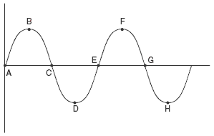
- Amplitude ______________________
- Wavelength ______________________
- Crest ______________________
- Trough ______________________
3. The audio frequency oscillator was producing the following sound wave on the cathode ray oscilloscope.

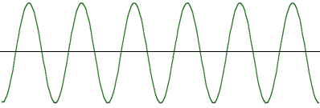
a) Draw below what the wave will look like if the frequency of the sound were to increase (2 marks)

b) Draw below what the wave will look like if the original sound were louder (2 marks)

4. Explain why a stationary observer will hear a difference in pitch as a moving vehicle passes them. Use your knowledge of the Doppler Effect to answer this question. (4 marks)
______________________________________________________________________________
______________________________________________________________________________
______________________________________________________________________________
______________________________________________________________________________
______________________________________________________________________________
______________________________________________________________________________
5. A person who is blind wants to buy a house that has large rooms. They are able to gauge the size of a room by clicking. Explain how this is possible by using your knowledge of how sound travels. (3 marks)
______________________________________________________________________________
______________________________________________________________________________
______________________________________________________________________________
______________________________________________________________________________

6. Draw a diagram of a light ray hitting a mirror and obeying the Law of Reflection. Be sure to label the normal, the angle of incidence and angle of reflection. (4 marks)

7. Define the following terms and give an example of an object that is (6 marks)

- Transparent
___________________________________________________________________________
___________________________________________________________________________
- Translucent
___________________________________________________________________________
___________________________________________________________________________
- Opaque
____________________________________________________________________________
____________________________________________________________________________
8. Isaac Newton identified the seven colours of the rainbow. (3.5 marks)
What are they?

R_____________________
O_____________________
Y_____________________
G_____________________
B_____________________
I______________________
V_____________________

- What are the three primary colours for light? (1.5marks)

- ______________________________
- _____________________________
- _____________________________

- Explain why they are called the primary colours of light (1 mark)

___________________________________________________________________________
___________________________________________________________________________
END OF TEST

